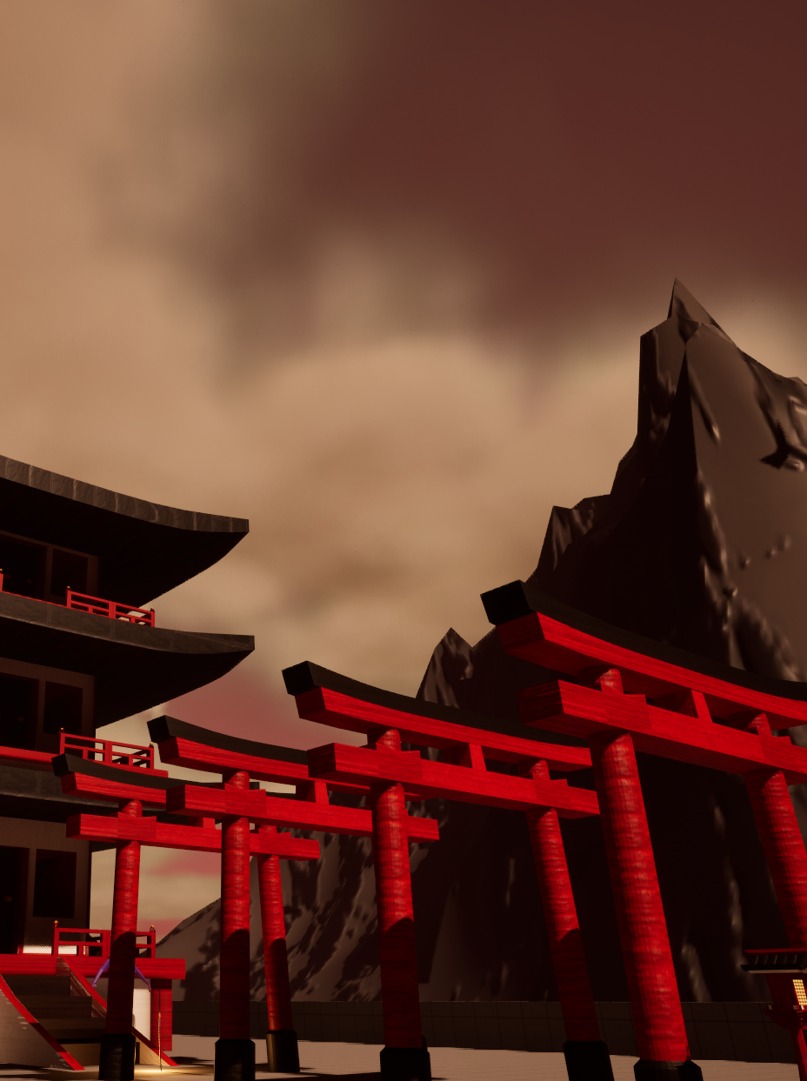

**Jinkonooi**

Written by Dylan Dennis St20231722

Contact Info – [St20231722@cardiffmet.ac.uk](mailto:St20231722@cardiffmet.ac.uk)

Date Of Publishing 15/12/2023

Version Number v1.0

**Table Of Contents**

Cover Image………………………………………………………………………………………………………………………….1

Game Title and Info………………………………………………………………………………………………………………2

Table of Contents………………………………………………………………………………………………………………….3

TDD Outline………………………………………………………………………………………………………………………….3

Minimum Specifications……………………………………………………………………………………………………….3

Equipment……………………………………………………………………………………………………………………………4

Development requirements…………………………………………………………………………………………………4

Asset Specifications………………………………………………………………………………………………………………5

Development Plan………………………………………………………………………………………………………………..5

Milestones……………………………………………………………………………………………………………………………6

Playtesting……………………………………………………………………………………………………………………………6

**TDD Outline**

Jinkonooi will be developed in approximately one month by myself with the use of the Unreal Engine game engine. Blender and 3DS Max will be used for the 3D asset creation and Photoshop used for texture and mapping creation. The project will use GitHub as a version control solution and audacity will be used for audio creation and editing to create sound effects.

**Minimum Specifications**

Intel core i5-7600K

Nvidia GTX 1080

Windows 10 64 bit OS

8 GB DDR4 RAM

**Equipment**

Hardware – Development efforts will utilize a Windows PC as well as an Asus laptop for the asset creation and development throughout the course of this project. Aswell as various other windows PCs used periodically throughout development.

|  |  |
| --- | --- |
| Hardware | Task |
| Windows Pc | Asset Creation  Game Development  Texture Creation |
| ASUS TUF F15 Windows Laptop | Asset Creation  Game Development  Texture Creation |
| Huion Kamvas Pro 24 | Texture Creation |

**Development Requirements**

|  |  |  |
| --- | --- | --- |
| Software | Version | Task |
| Unreal Engine 5 | 5.3.1 | Game Engine / Development |
| 3DS Max 2024 | 26.2.0.22013 | 3D Asset Modelling |
| Blender | 4.0.2 | 3D Asset Modelling  3D Animation |
| Adobe Photoshop 2024 | 25.2 | Texture Creation |
| Audacity | 3.4.2 | Sound Effect Creation |
| GitHub Desktop | 3.3.5 | Version Control |

**ASSET SPECIFICATIONS**

|  |  |  |  |
| --- | --- | --- | --- |
| Asset Type | Naming Convention | File Format | Notes |
| 3D Models | ModelName | .FBX  .Blend  .MAX | Final models use FBX as it is a general 3D format |
| Textures | ModelName_TextureType | .TIFF  .TARGA |  |
| Reference Images | AssetName | .JPEG  .PNG | Reference Images are not assigned any set naming convention |
| Animations | AnimationSegmentName | Contained within the models file |  |
| Sound Clips | SoundName | .WAV |  |

|  |  |  |  |
| --- | --- | --- | --- |
| Model Name | Poly Count | Modeled With | UV Textured With |
| KatanaModel | 424 | 3DS Max | 3DS Max |
| PagodaModel | 8,710 | Blender | Blender |
| CharacterModel | 378 | Blender | Blender |
| TerrainModel | 2,500 | Blender | Blender |
| TorriGateModel | 740 | Blender | Blender |
| LampModel | 1,114 | 3DS Max / Blender | Blender |
| Total | 13,866 |

**Development Plan**

|  |  |  |  |  |
| --- | --- | --- | --- | --- |
| Task | Week 1 | Week 2 | Week 3 | Week 4 |
| 3D Asset Creation | Reference Collection  Modelling | Modelling | Final Modelling  Texture Application | Texture Application |
| Texture Creation | Reference Collection | Texture Creation | Texture Creation | Final Texture Creation |
| Engine Implementation |  | Importing Basic Assets | Importing Textured Assets  Designing Level Layout | Final Asset Imports  Tweaks |
| Audio |  |  |  | Audio Recording  Audio Manipulation |
| Testing |  |  | Testing | Export Testing |

**Milestones**

|  |  |
| --- | --- |
| Date | Achievement |
| 8/12/2023 | Basic Model Imports |
| 10/12/2023 | Sound Imported |
| 12/12/2023 | Prototype Built |

**Play Testing Overview**

I Did several playtests where I would ensure movement and sounds were being correctly controlled and registered.